CBOEDirect
GC Dependency Analysis
CBOEDIR_x.x

April 28, 2006

Prepared By: Ravi Nagayach

GC Dependency 1
Requirement 1
Requirement issues/Assumptions 1
Design consideratios for global services 2
General Design consideration for maintaining GC service on BC 2
Service architecture for global services 3
Service and Task list for GC Dependency 8
Project phases 15
Phase 1 15
Phase 2 15
Phase 3 16

GC Dependency

Requirement
Currently any problem with global cluster causes the problem on all the BC. Aim of this project is to minimize the business clusters dependency on global cluster, so that BCs are ready for trading even though there are problems with the global cluster.

Requirement issues/Assumptions
- If BC’s are running without the Global, Do we need to do the additive tasks such as
- Add products, add users
- Update user, disable/enable users
- Stock split at the EOD
- To build the route map FE’s would need the persistence, are we going to have DB on FEs?
- Does intraday add on Global, when global is running fine, needs to be picked up by global service on BC continiously OR Is it ok if we synch up the global service related DB on BC at the EOD.
- Do we want to look in direction to move the services off from global to BCs?

Design consideratios for global services

General Design consideration for maintaining GC service on BC
- In moving any service to bc, we should consider that we don’t end up with two versions of services, one running on the gc and another running on the bc, i.e. same version should run on the global as well as BC. We might have to make appropriate changes on the existing services. So for TSS we should use the TSSLocalImpl on the BC as well as on the GC. The database tables and columns will be same on BC and GC.
- How are we going to take care of calls with key, i.e. getElementsByKey or getProductByKey? Because maintaining the GC data on BC with same tables will create different DatabaseId’s?
  - We will have one additional column, GlobalDBId, on each table being moved to BC. This column will be null on global box. On BC box it will contain the DBId of the record on the global box.
  - Any other options?
- ProxyService – All the global services on the BC, will have a switch to use either the global box or business box to use the global service. It seems that global service on BC will not need to be exported.?
- FE’s will also need to have the database as to create the routing map they would need the PCS information.

Service architecture for global services
Various options for service architecture for global services are listed below:
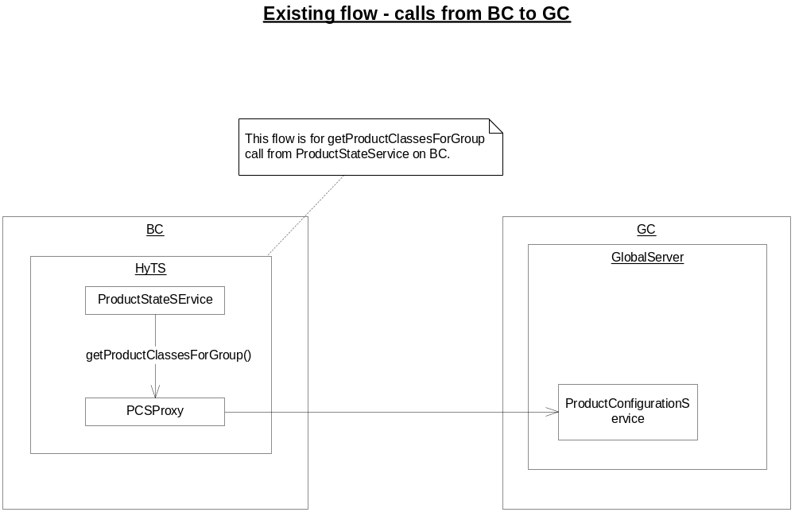

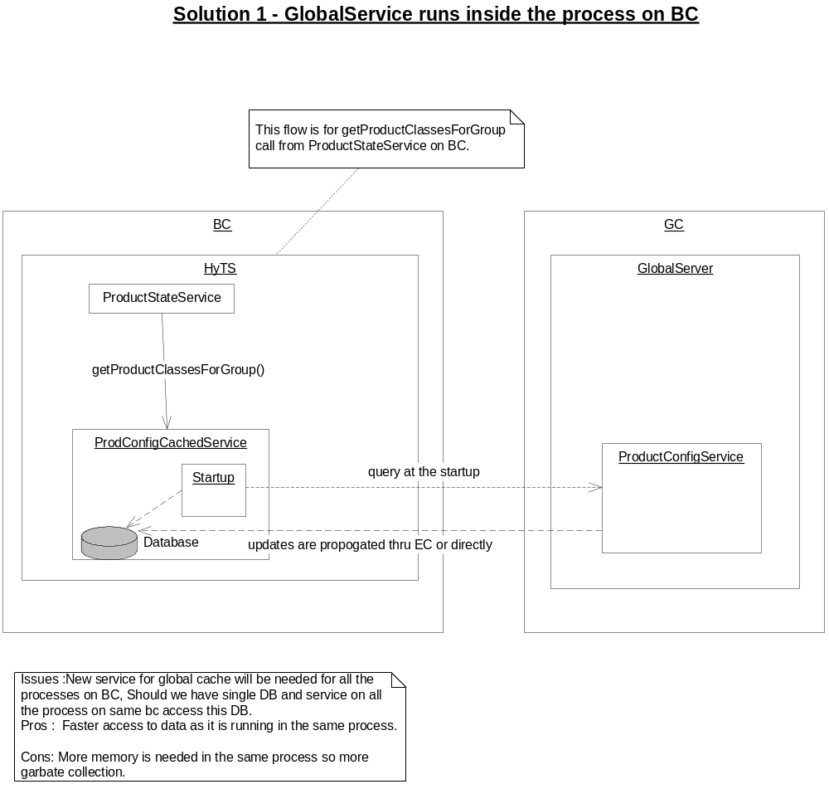

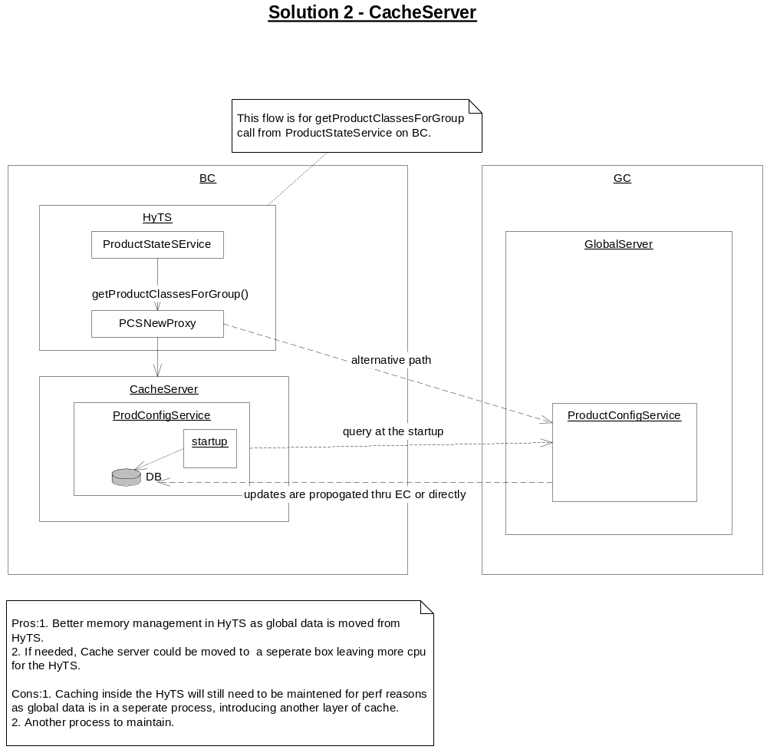
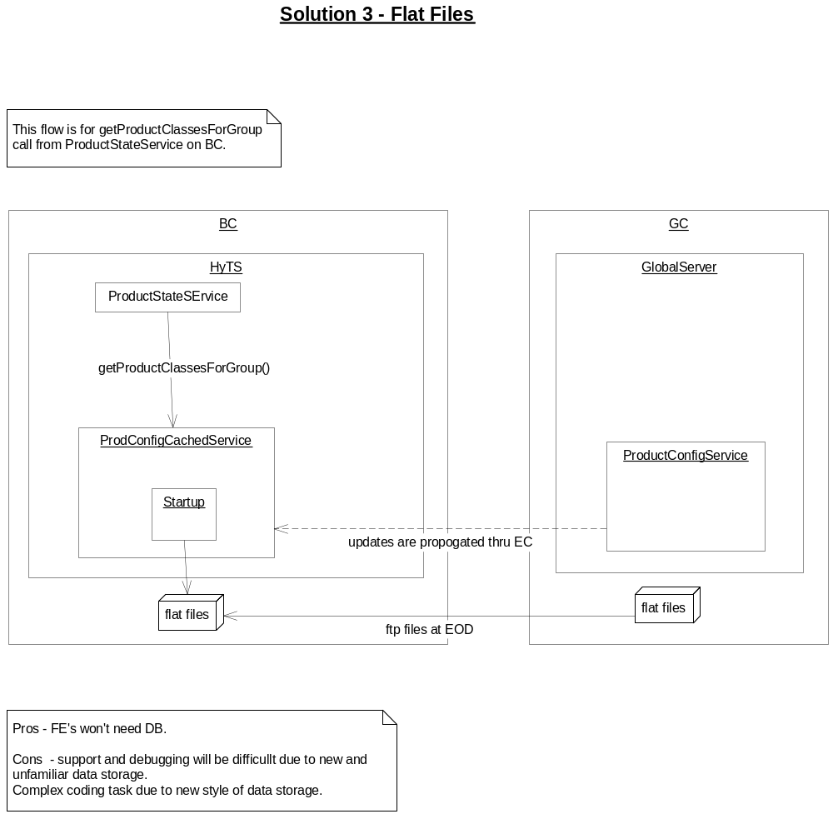
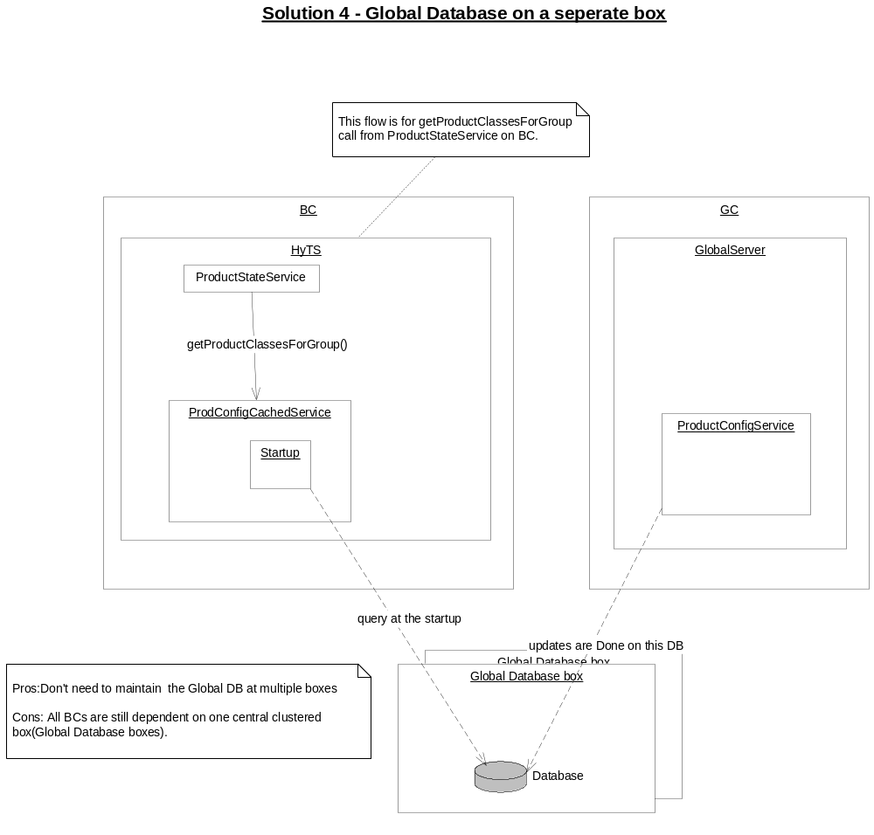

Service and Task list for GC Dependency

No. | Service Name | Used by BC | Tasks  - Sub tasks
 | TradingSessionService/ TradingSessionMaintenanceService | Yes | Create current business day  - Create current day session for all the templates  - Add classes to trading session templates  - Add timers for start/end session and product state changes  - Create business day.  Start session  - Global sends “prepare start of session”  - HyTS gets classes for group and session from global, and  - Add classes to session  - Global sends “start of session”  - HyTS creats market data for all the products, and  - Creates order book, and  - Changes the product states to CLOSE  End Session  - Global sends “prepare end of session”  - HyTS moves products to no session state.  - Global sends “Start end of session events”  - HyTS resets the session specific values for orders.  - Global sends “ending session” event.  - HyTS purges order books for all the products  - Global sends “completed end of session” event.  - HyTS removes classes from the session.  End of Day  - Price adjustment info is received from IPD and applied on the GC.  - HyTS receives the price adj info and adjust the orders  - Global publishes “purge session”  - HyTS would purg the order.  - Global publishes “post purge validation” and “end of day” events  Create Strategies  - Create the strategy product and add to the sessions.  Open hybrid products with underlying ticker.  - Underlying tick is picked by the the global server and after few checkes open the product class.  Trading session history.  - All the session related events – start, end and their completion – are stored in global server and these can be queried from the SAGUI.
 | TradingPropertyService / PropertyService / TPSPropertyServiceFacade | Yes | GetXYZProperty.  - Finds the property from the cache or DB.  Get Properties by type and category.  - Use new property service to find the property by type and category  Dynamic property update on GC.  - During the trade time when properties are updated publishes the property update event, HyTS picks up this and might reset the cache to use this in next operation.
 | ProductQueryService | Yes | Get product, class or strategy  - By name  - By key  - By class
 | ProductMaintenanceService | Yes | Find the products by following parameters  - qpe enabled Classes  - open intersts  - price adjustments  - transaction fee codes  - settlment for classes  Additive operations  - Add products  - Add product class  - Add reporting class  - Enable/disable qpe flags  - Apply price adjustments
 | UserServiceHome | Yes | Find the following info based upon user key or user acronym  - User  - User session profile  - User enablements
 | UserMaintenanceServiceHome | Yes | Get affiliated firms for user  Get Dpm’s for  - class  - joint accounts.  Get users by following information  - by user role  - by user type  - by assigned class  - by acr  Get session profile by key/id/acr  Add users  Add session profile user
 | UserTradingParameterServiceHome | Yes | For a user find the following info  - Quote risk management flag, whether enabled or disabled.  - Quote risk profile for class  - Default Quote risk profile  Enable/disable Quote risk management.  Set/update quote risk prfile for users.
 | FirmMaintenanceServiceHome / FirmServiceHome | Yes | Find the firms by  - Key  - Acronym  - Number  Add firms
 | AlertServiceHome | Yes | Find alerts by search criterion  Find alerts by alert id.  Create satisfaction alerts.  Resolve alerts.
 | ProductConfigurationServiceHome | Yes | Create  - Group type  - Group  Add  - Sub groups  - Product classes to group  Find/get  - Group key for product/class  - Products by group  - Sub groups  Remove  - Sub groups/ungroup  - Product classes from group
 | ProductRoutingServiceHome | Yes | Get route name by class/product.  Update route map for new product or strategy.
 | ProductStateServiceHome | Yes | Add product/strategy  Get settlement prices for class  Change product state by  - class  - product  - group  Publish product state changes
 | MarketDataServiceHome | Yes | Accept and cache  - Current market  - Product state changes  - BOTR and exchange indicators  - EOP  - Recap  - Ticker  Find/Get  - Product history by time  - Quote query data for product  - Underlying recap for derivative  - Current market product product/class  - Closing Quote summary  - NBBO for class/product  - Recap for class/product
 | UserActivityServiceHome | Yes | Find/Get  - Trader class activity by time  - Trader product activity by time  - Last user activity by time
 | TIPSProductService | No
 | SecurityAdminService | No
 | UserDefinitionServiceHome | No
 | TextMessagingServiceHome | No
 | MarketDataSummaryServiceHome | No
 | OrderMaintenanceServiceHome | No

Project phases
Because of changes which affects the service architecutre, database and routing and need changes in many services, we would propose that this project is done in 3 phases. Each phase will gradually reduce the BC dependency on global. And in every phase we would move the time, when global needs to be fully up, away from its current limits, i.e. after first phase global could be started as late as the time for start session, after phase 2 global could be started as late as the time for product rotation and third phase will try to reduce the global dependency even further.

Phase 1
First phase will aim to start all the BC processes without the global server.
This will involve the following tasks
- Select a service architecture for global services from any of 4 proposed architecture or something new.
- Detail design of selected service architecture.
- Pick any one service for implementation.
- Design and code for service, This would involve
- Database tables/design to persist the data on BC.
- New Database might be required on FEs.
- Changes in the global service so that same code could be used transparently on Global and BC.
- New routing proxy to talk to Global service running on BC or GC.
- For failover, change scripts and code to switch global service between global or BC version.
- After testing one service, port other services, This task could be a phase in its own.

Benefits of this phase are that when global is having a problem we could start all the BCs without global and global could be fixed and started as late as upto the start session timer.

Phase 2
This phase will deal with moving the controller functionalities on the BC.
Controller functions, which are currently executed on the global, should be able to execute from the BC and without the global.
Few example of these functions are
- Create business day.
- Start/end session
- Product timers for pre-open, OR and close
- Processing underlying ticker to open the products
- Underlying Market Data query to MDGC

This phase will also support updating the BC’s local cache intraday.

Benefits of this phase are that when global is having a problem we could start the all the BC, start the session and open the products without the global. As soon as global is up, user could and system will be ready for trading.
This won’t eliminate the outage in case of global problem but it will definetly reduce the outage time because as soon as global is started system will be ready for trading.

Phase 3
Third phase will try to support some adminstrative/SAGUI functionalities and will attempt to move few services/functionalities away from global.
Few example of these changes are:-
- SAGUI query for trading session history and status.
- Price adjustment processing on BCs.
- End of day processing on BCs.
- Update/Add products intraday
- User login.

Benefits of this phase are that when global is having a problem we could start the BC and do the trading without the global server.

